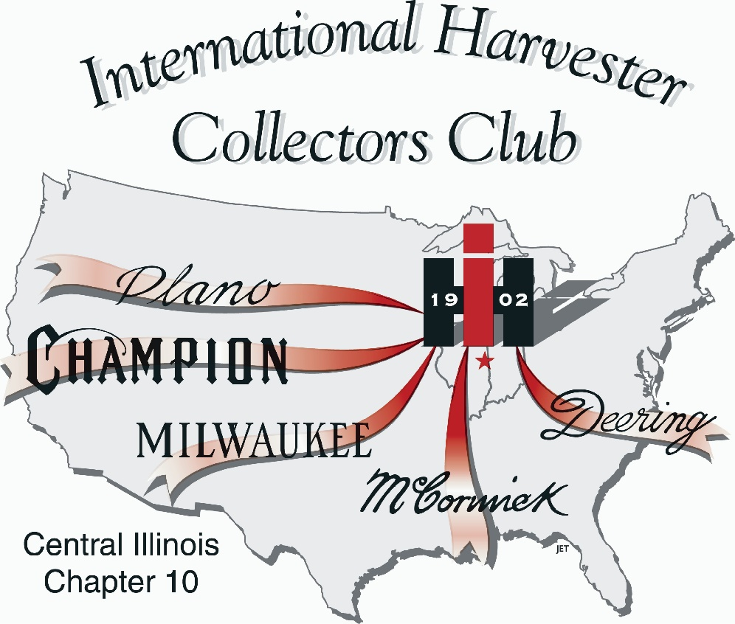-

Chapter 10
P.O. Box 66
Penfield, IL 61862
Hello from East Central Illinois,

I assume most of you know where we live. We are six miles north of St. Joseph, IL; ten miles from Penfield to the northeast and ten miles from Rantoul to the northwest. That is one reason we are involved with I&I Club’s Historic Farm Days in Penfield and Half Century of Progress in Rantoul.

We had a very busy summer with the I&I Show in July which featured John Deere this year. We always have the Chapter 10 IH Room in the Penfield School open for visitors during the Show. We were also busy working on getting tractors for our 100 Years of Farmall display at Half Century which took place in Rantoul in August. About five days before the Half Century Show, we found out we had completed our project with LOTS of help from members and friends. We came up with an International Harvester or Farmall from every year, actually displaying 101 tractors from 1923-2023. A special THANKS to all who helped. I give Rollie and Fran Moore a lot of credit for keeping track of all the tractors and figuring out how to display them at the show. It was a spectacular display; the pictures don’t do it justice. You needed to be there to take it in. We had close to 300 tractors in the IH feature area surrounding the Chapter 10 tent and 100 in the Farmall exhibit, along with a number of red tractors in the Family Heritage tractor display for a total of over 400 IH tractors at Half Century. We greatly appreciate all who brought tractors to be displayed at the show. It takes a lot of help to put on a show like this and I want to personally thank everyone who helped at our booth in the Chapter 10 tent or just showed up to display anything IH.

If that wasn’t enough to do, right after Half Century, we wanted to get 70 Farmalls to have a tractor drive to the Farm Progress Show (FPS) in Decatur for the FPS 70th anniversary. The 42 mile drive started on Monday morning, August 28 at 7 a.m. at Central Illinois Ag in Farmer City and went to the FPS site where the Farmalls were on display on the north side of the showgrounds. The tractor drive was sponsored by CaseIH and the FPS. We didn’t quite make it to 70 tractors, but came very close with 64 on display. Thanks to FPS and CaseIH and all who drove or brought tractors to Decatur for the display. Thanks also to the Piatt County Farm Bureau for providing snacks at our stop in Cisco, IL.

J.C. Reitmeier
President

Come join us
Friday, November 10, 11:30 a.m.
Lunch at Richards Farm Restaurant
607 NE 13th St., Casey, IL.
After lunch we will visit
Forsyth Family Farms Farmall Collection
18240 E 2150th Rd, Marshall, IL.
Call Chuck Hoene at 217 663-3768 or J.C. at 217 841-8842 by Wednesday, November 8 to reserve your spot.
Message from Rollie

What an exciting time for IH enthusiasts! Two great big events….The line up at HCOP of 100 Farmalls from 1923 to 2023. YES we got one for each year. That couldn’t have been done without the awesome help of some key individuals. Four directors put in extra effort to find the needed years for the line-up: J.C. Reitmeier, Chuck Hoene and Kurt Jansen. Steve Appl braved the rain showers Sunday morning to help measure out 100 spaces for the tractors. Three individuals were extra committed to find the newer, big tractors from local farms: Bill Flavin, Ryan Musson, and Dyke Shaffer. Without their work we might have had at least 15 empty spots. We thank Central Illinois Ag and Doug Franzen for their help in making the tractor drive from Farmer City to the Farm Progress Show a big Success. Marvin Johnson was also a big help.
If you brought a tractor to Rantoul, or had your tractor part of the display at Decatur we offer you our heartfelt thanks. And I’d be remiss not to thank Fran for her help during the last nine months!

Message from Karen

What a summer! It was hot at Rantoul. We had great sales at both our Penfield and Rantoul shows. If only our t-shirts would have arrived BEFORE Rantoul. They arrived the Tuesday after the show. Oh well, we’ll have them to sell at Louisville. Did I mention how hot it was in Rantoul and dusty? Well, Sunday morning it turned cool and thankfully we had zippered sweatshirts to sell. We probably sold a dozen.

We had a great backdrop located in our tent. The guys from CaseIH were located right next to us and didn’t have room to display it, so we had the privilege of having it under our tent and it sure garnered a lot of attention from people. Sunday morning six gentlemen from France walked into the tent and it didn’t take long for Jerry Edwards and I to figure out that we didn’t speak the same language. They were interested in buying hats, so I held up a $20 bill and one finger and we got our prices figured out. They ended up buying a number of items and Jerry did a great job helping them out. I led them over to the backdrop and took their picture, telling them to say “cheese.” They understood that and seeing six Frenchmen saying cheese for a photo-op made me chuckle inside. We had fun.

A lot of people came through the tent at Rantoul. It was so good to see Lloyd and Loretta Schrowang and Russell and Maxine Stewart. They braved the heat to see the Show and the 100 years of Farmall.

I’ve included some pictures from Rantoul and one from the tractor drive. I didn’t get as many pictures as I thought from the tractors displayed around the tent. A Half Century of Progress book will be published and I know Chandler Bruns took a lot of drone pictures, so I can’t wait until the book comes out. I was not directly involved with getting the tractors together, but I know A LOT of emails and phone calls were being made to pull this off. The guys and Fran did a fantastic job!

On to harvest: I got a great birthday present, an electric tarp for the grain truck! We look forward to seeing everyone in Louisville in February 2024.
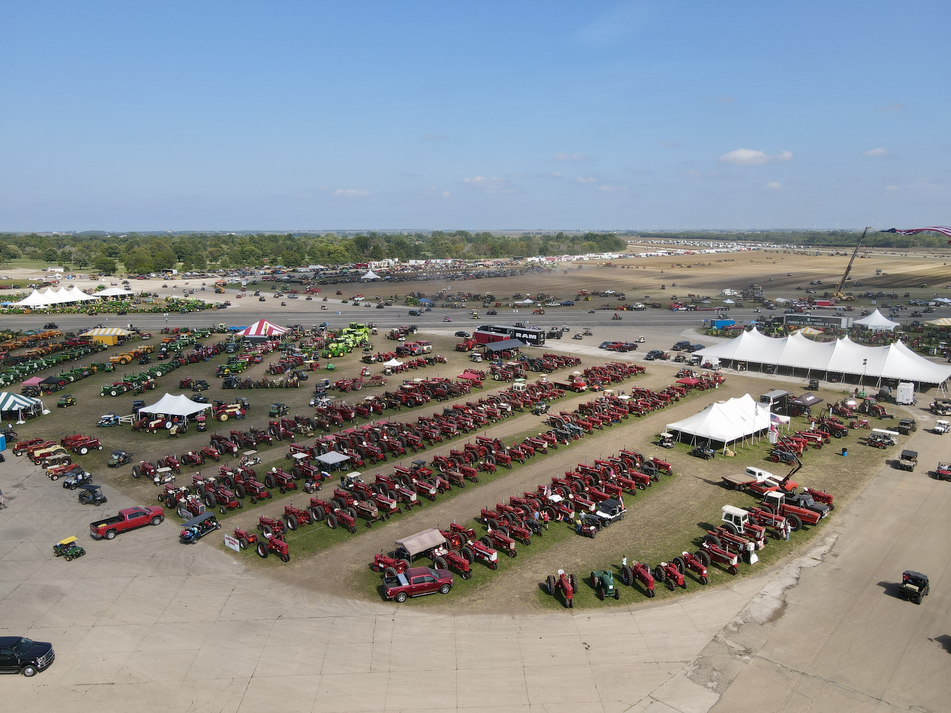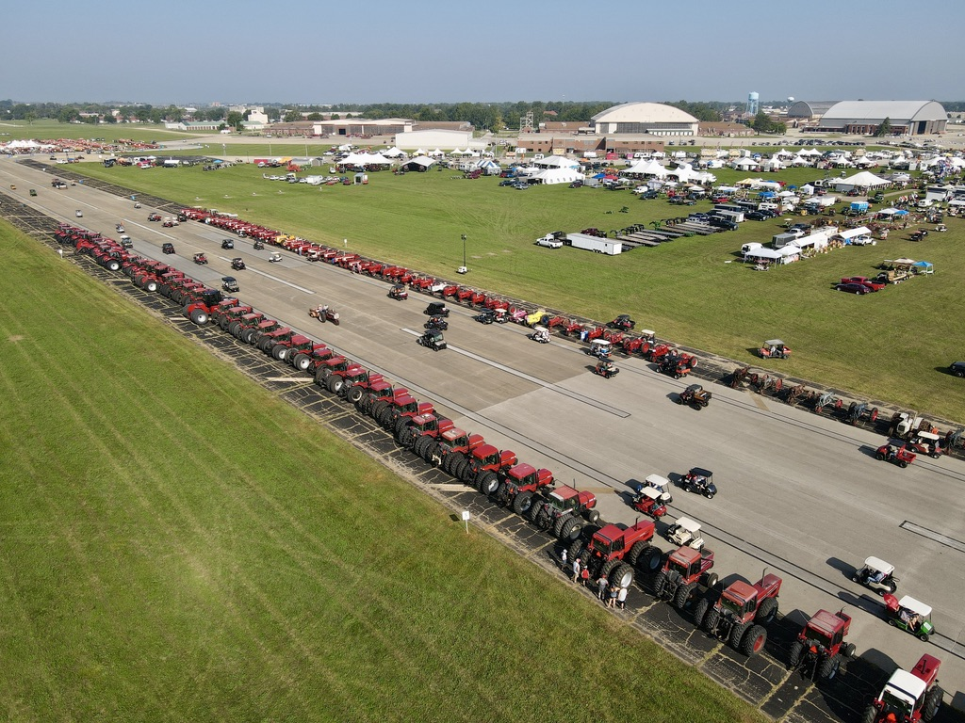
IH area at Half Century of Progress 2023 100 years of Farmall at Rantoul

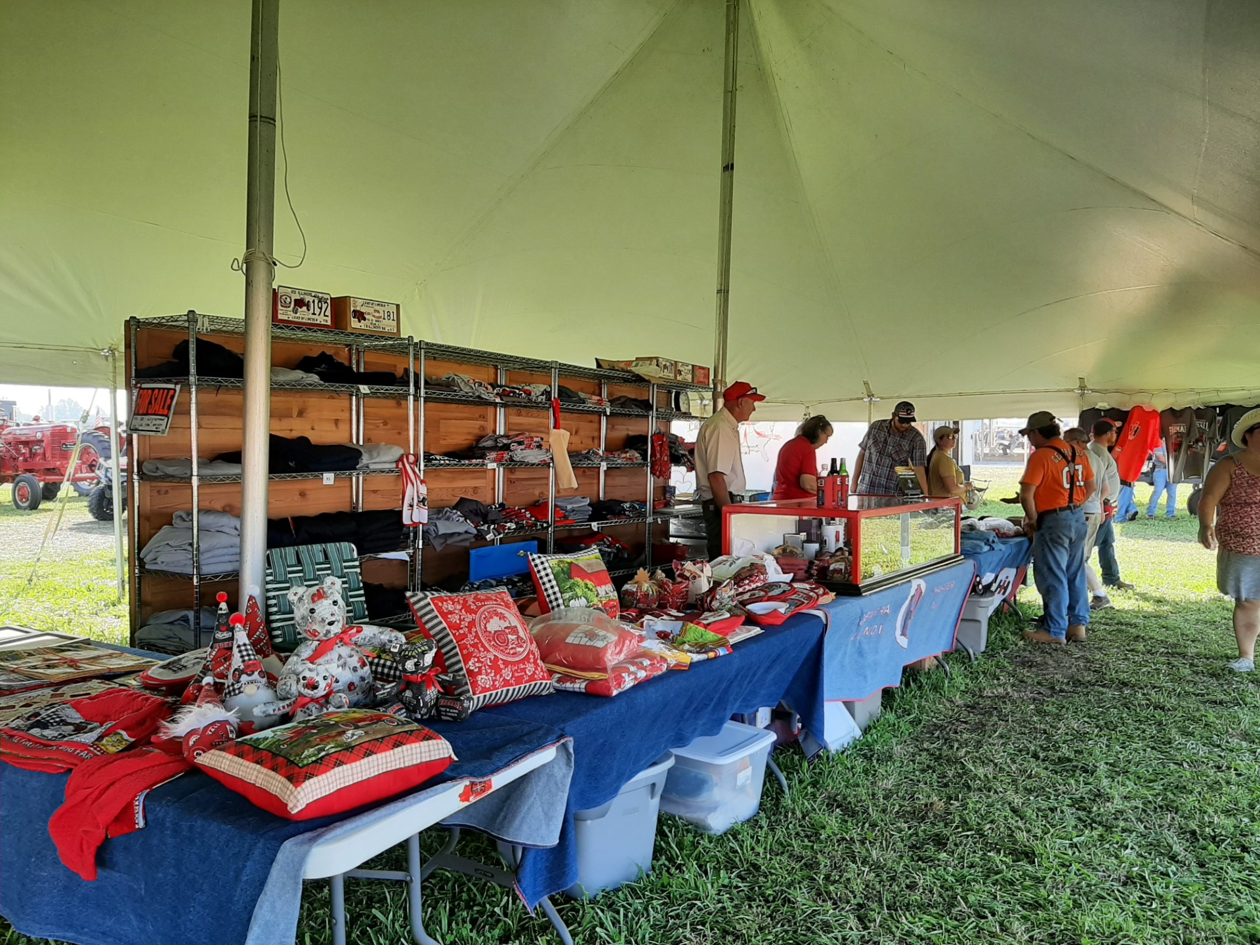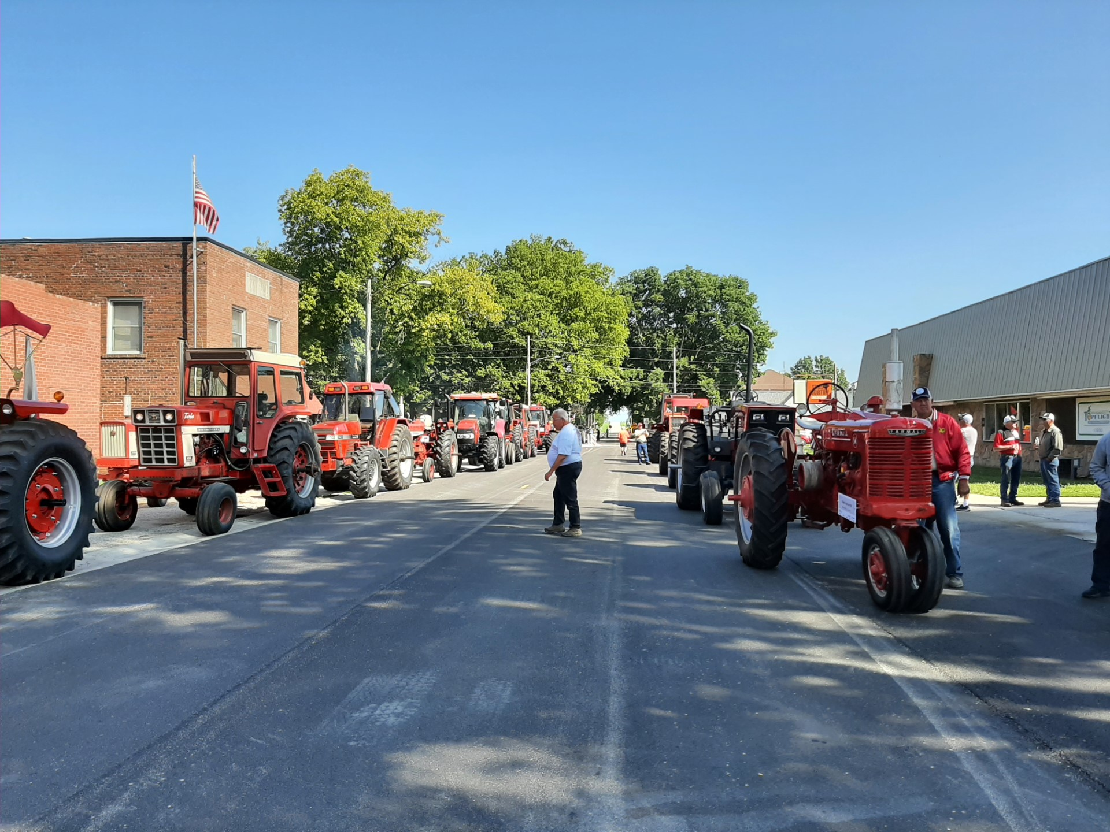
Chapter 10 booth at HCOP FPS Tractor Drive stopped in Cisco

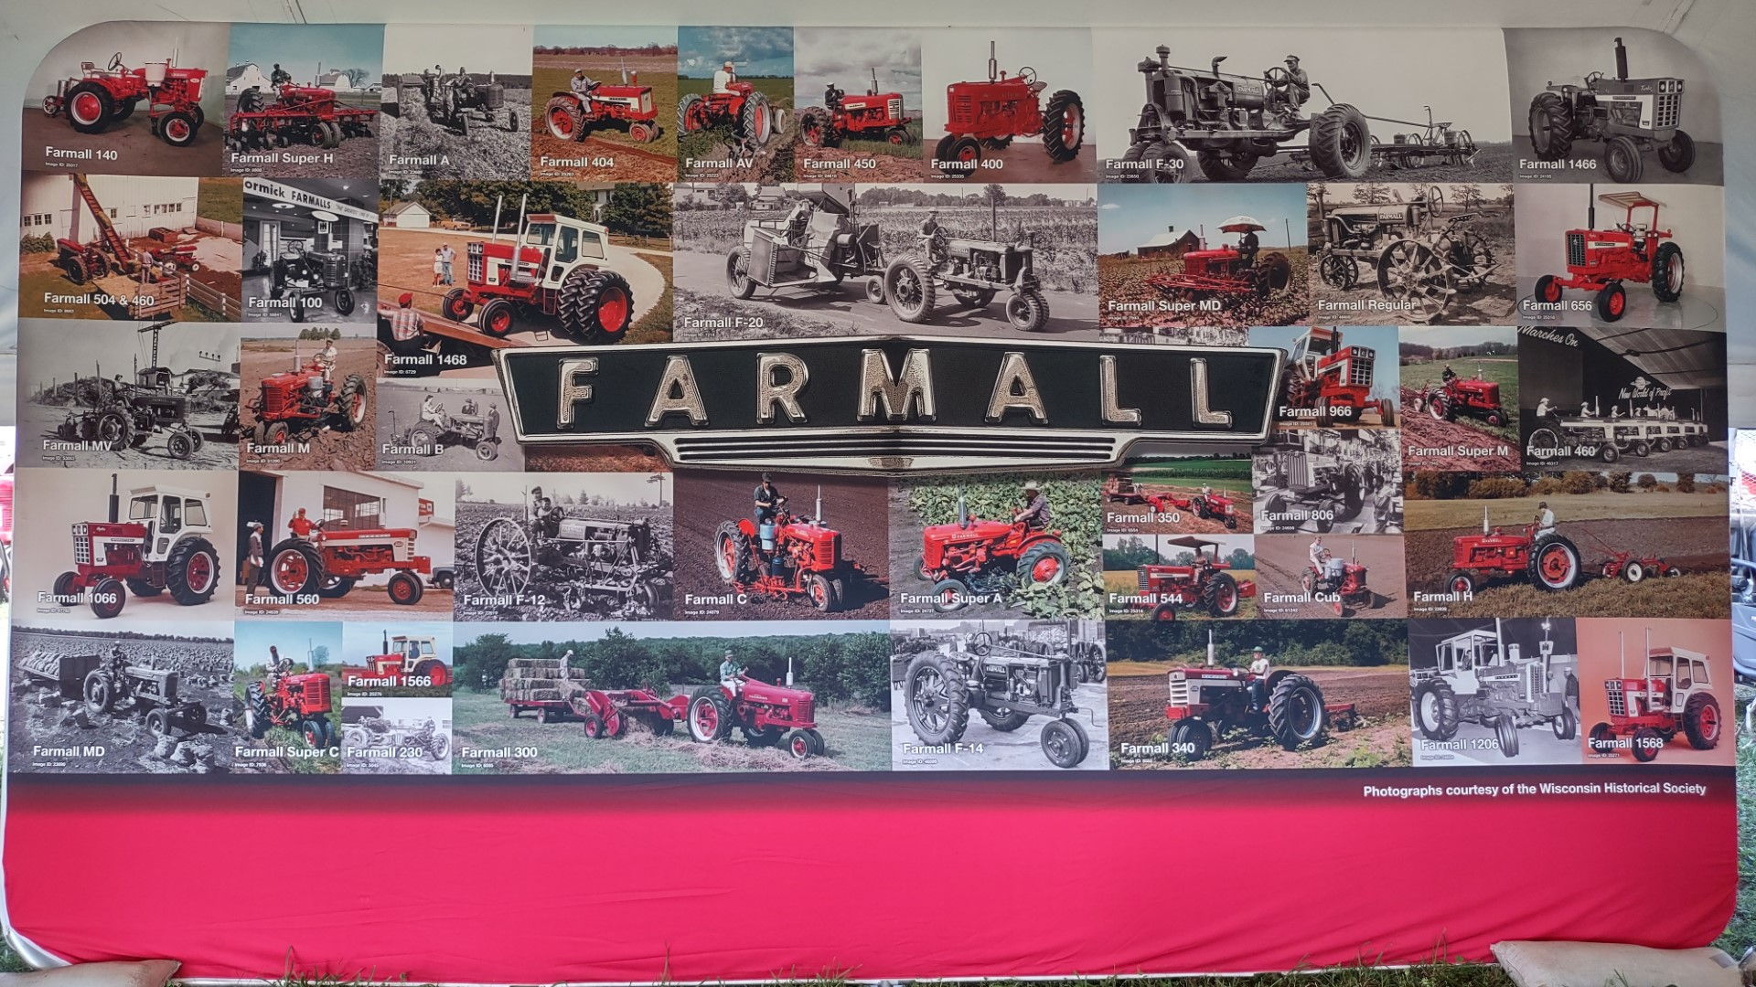
Case IH Farmall banner displayed in Chapter 10 tent at HCOP

DUES NOTICE DUES NOTICE DUES NOTICE
Chapter 10 International Harvester Collectors Club
- This is your Chapter 10 and National IH Collectors dues notice for 2023.
- Send a check for $30 ($10 local, $20 National IF PAID BY DECEMBER 1)
payable to: IH Collectors Chapter 10
and mail to: 662 Knox Rd. 2600 N., Oneida, IL 61467
Please pay by October 31. National expects us to turn in your dues during October. If National doesn’t receive your dues during December they will CANCEL you. STRAGGLING DUES RETURNS MAKE A LOT OF EXTRA WORK!!!!! PLEASE PAY PROMPTLY!!!!
Thank you for continuing to support Chapter 10
DUES INCREASE FROM NATIONAL IS HERE!!!!
National IH Collectors have decided to increase their dues from $15 to $20 for 2023.
Chapter 10 dues are always collected in October. If you didn’t pay until March, April, May or June as some members have, your dues are STILL due in October. Return the slip below with your check. ( putting dues notice in this newsletter saves your club over $150 in mailing costs)

Name: ________________________________________________

Change of address? _____________________________________
______________________________________________________

Share your email address? ________________________________

Upcoming Events:

November 3-4, 2023 Chapter 32 National Collectors Auction, Pinckneyville, IL.

November 10, 2023 Chapter 10 Luncheon at Richards Farm Restaurant and Forsyth Family Farms Farmall Collection.

February 8-10, 2024 Kansas Chapter 3 Winter Convention, Salina, KS. Go to: www.inckansas3.org for more information.

February 14-17, 2024 National Farm Machinery Show, Louisville, KY.

June 20-23, 2024 35th Annual Red Power Round Up, hosted by Iowa Chapter 5, Spencer, IA.

June 26-28, 2025 36th Annual Red Power Round Up, hosted by Missouri Chapter 31, Sedalia, MO.

FOR SALE

Restored 1941 International K 5. Contact Marchael L. Page at 317 508-5483.

Directors

J.C. Reitmeier, Pres. Derek Harms, V.P. Jerry Edwards, V.P. Karen Reitmeier, Sec.
2217 CR, 2200 E 2312 CR 2200 N 3407 North 1350 East 2217 CR, 2200E
St. Joseph, IL 61873 St. Joseph, IL 61873 Mansfield, IL 61854 St. Joseph, IL 61873
217 841-8842 217 202-0972 217 489-9295 217 649-3403

Chuck Hoene, Treas. Rollie Moore, Mem. Ch. Steve Appl Stan Dietz
719 CR, 500 N 662 Knox Rd. 2600 N. 1582 E. 3200 N. Rd.
Toledo, IL 62468 Oneida, IL 61467 St. Joseph, IL 61873 Piper City, IL 60959
217 849-3675 309 483-6431 217 202-7526 815 674-2306

Kurt Jansen Roger Musson Duane Stone Carl Vandevender
20102 N. 1350th St. 408 W. 2nd St. Box 146 3278 Clevenger Rd. 4741 E. CR, 400 South
Effingham, IL 62401 Sadorus, IL 61872 Waverly, IL 62692 Frankfort, IN 46041
217 663-8634 217 369-2383 217 435-4751 765-659-1917

